

Semester One Examination, 2022

Question/Answer booklet

MATHEMATICS METHODS
UNIT 3

Section One:

Calculator-free

Your Name:
Your Teacher’s Name:

Time allowed for this section
Reading time before commencing work: five minutes
Working time: fifty minutes

Materials required/recommended for this section
To be provided by the supervisor
This Question/Answer booklet
Formula sheet

To be provided by the candidate
Standard items: pens (blue/black preferred), pencils (including coloured), sharpener, correction fluid/tape, eraser, ruler, highlighters

Special items: nil

Important note to candidates
No other items may be taken into the examination room. It is your responsibility to ensure that you do not have any unauthorised material. If you have any unauthorised material with you, hand it to the supervisor before reading any further.

Question | Marks | Max | Question | Marks | Max
1 |  | 8 | 5 |  | 6
2 |  | 10 | 6 |  | 13
3 |  | 8
4 |  | 8

Structure of this paper

Section | Number of questions available | Number of questions to be answered | Working time (minutes) | Marks available | Percentage of examination
Section One:  Calculator-free | 6 | 6 | 50 | 53 | 35
Section Two:  Calculator-assumed | 12 | 12 | 100 | 100 | 65
 |  |  |  | Total | 100

Instructions to candidates

- The rules for the conduct of the Western Australian Certificate of Education ATAR course examinations are detailed in the Year 12 Information Handbook 2019. Sitting this examination implies that you agree to abide by these rules.

- Write your answers in this Question/Answer booklet.

- You must be careful to confine your answers to the specific questions asked and to follow any instructions that are specific to a particular question.

- Additional pages for the use of planning your answer to a question or continuing your answer to a question have been provided at the end of this Question/Answer booklet. If you use the space to continue an answer, indicate in the original answer space where the answer is continued, i.e. give the page number.

- Show all your working clearly. Your working should be in sufficient detail to allow your answers to be checked readily and for marks to be awarded for reasoning. Incorrect answers given without supporting reasoning cannot be allocated any marks. For any question or part question worth more than two marks, valid working or justification is required to receive full marks. If you repeat any question, ensure that you cancel the answer you do not wish to have marked.

- It is recommended that you do not use pencil, except in diagrams.

- The Formula sheet is not to be handed in with your Question/Answer booklet.

Section One: Calculator-free (53 marks)

This section has six questions. Answer all questions. Write your answers in the spaces provided.

Spare pages are included at the end of this booklet. They can be used for planning your responses and/or as additional space if required to continue an answer.
● Planning: If you use the spare pages for planning, indicate this clearly at the top of the page.
● Continuing an answer: If you need to use the space to continue an answer, indicate in the original answer space where the answer is continued, i.e. give the page number. Fill in the number of the question that you are continuing to answer at the top of the page.

Working time: 50 minutes.

Question 1 (8 marks)
The function $f$ is defined for $x>0$ by $f\left(x\right)=\begin{matrix}e^{4x-1} \\ \overline{ \overset{ }{x} }\end{matrix}$, and $f^{''}\left(x\right)=\begin{matrix}2\left(8x^{2}-4x+1\right)e^{4x-1} \\ \overline{{ x}^{3} }\end{matrix}$.

- Show that $f'(x)=\frac{e^{4x-1}\left(4x-1\right)}{x^{2}}$ (2 marks)

Solution
$$f^{'}\left(x\right)=\frac{x\left(4e^{4x-1}\right)-e^{4x-1}}{x^{2}}$$
$$f^{'}\left(x\right)=\frac{e^{4x-1}(4x-1)}{x^{2}}$$

Specific Behaviours
Shows the use of the quotient rule to determine $f'(x)$
ü Correctly determines $f'(x)$

- Determine the coordinates and nature of all stationary points of $y=f(x)$. Justify your answer. (4 marks)

Solution
$$0=\frac{e^{4x-1}(4x-1)}{x^{2}}$$
$$0=e^{4x-1}(4x-1)$$

$$x=\frac{1}{4}$$

$$f^{''}\left(\frac{1}{4}\right)=\begin{matrix}2\left(8{(\frac{1}{4})}^{2}-4(\frac{1}{4})+1\right)e^{4(\frac{1}{4})-1} \\ \overline{{ (\frac{1}{4})}^{3} }\end{matrix}=64$$

$∴$The stationary point at $x=\frac{1}{4}$ is a MINIMUM

$$f\left(\frac{1}{4}\right)=\begin{matrix}e^{4(\frac{1}{4})-1} \\ \overline{ \frac{1}{4} }\end{matrix}=4$$

$∴$The minimum turning point of the function occurs at $(\frac{1}{4},4)$

Specific Behaviours
ü Equates $f'(x)$ to zero, and solves for the $x$-coordinate of the stationary point (only $x=\frac{1}{4}$)
ü Uses the sign test or second derivative test to justify the nature of the $x$-coordinate
ü Correctly evaluates and interprets the nature of the stationary point
ü Correctly determines the coordinates of the stationary point

- Show that $y=f(x)$ has no points of inflection. (2 marks)

Solution
If there are points of inflection:

$$f^{''}\left(x\right)=\begin{matrix}2\left(8x^{2}-4x+1\right)e^{4x-1} \\ \overline{{ x}^{3} }\end{matrix}=0$$

$$2\left(8x^{2}-4x+1\right)e^{4x-1}=0$$
$$∴8x^{2}-4x+1=0$$
But if we use discriminants to obtain solutions:
$$b^{2}-4ac=16-4\left(8\right)\left(1\right)=-16$$
Since $b^{2}-4ac<0$ this shows that we have no solutions from the quadratic. Therefore, there will be no points of inflection to the function.

Specific Behaviours
ü Uses $f^{''}\left(x\right)=0$ (must equate the actual function for the second derivative to 0)
ü Uses the quadratic to explain why there are no points of inflection (either by discriminants, completing the square, or the quadratic formula)

Question 2 (10 marks)

The discrete random variable $X$ has a probability function with $Var(X) =\frac{14}{9}$
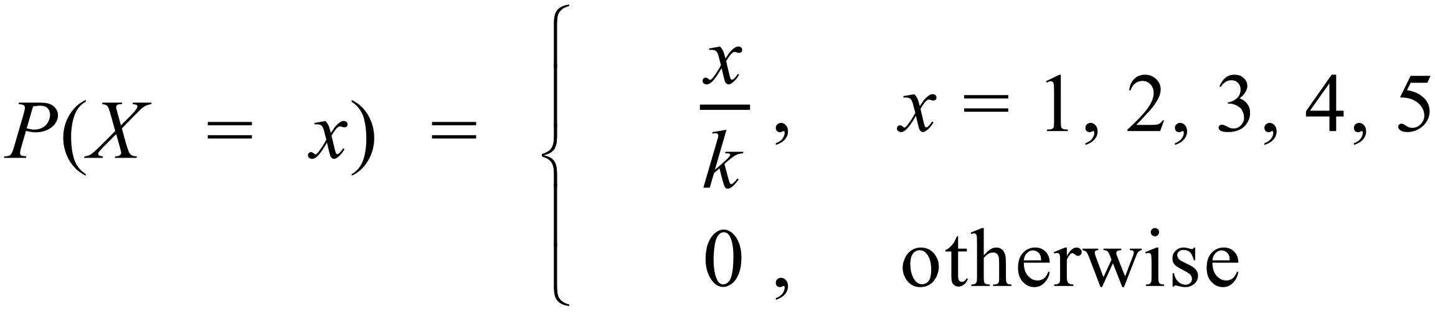

(a) Determine the value of $k$ (2 marks)

Solution
$$\frac{1+2+3+4+5}{k}=1$$

$$\frac{15}{k}=1$$
$$∴k=15$$

Specific Behaviours
Uses the sum of probabilities equal to 1 to establish an expression for finding $k$
ü Determines the value of $k$

Determine:

(b) (i) $P(X<4 | X>1)$ (2 marks)

Solution
$$P(X<4| X>1)=\frac{P(1<X<4)}{P(X>1)}$$
$$=\frac{\frac{2+3}{15}}{\frac{2+3+4+5}{15}}$$

$$∴P(X<4| X>1)=\frac{5}{14}$$

Specific Behaviours
Shows the correct numerator
ü Determines the correct conditional probability

(ii) $E(X)$ (2 marks)

Solution
$$E\left(X\right)=\frac{1+4+9+16+25}{15}=\frac{55}{15}$$

$$∴E\left(X\right)=\frac{11}{3}$$

Specific Behaviours
Shows the sum of each score with their respective probability
ü Determines $E(X)$

(c) A second discrete random variable $Y$ is defined to be $Y=aX+b.$
If $E(Y)=2$ and the standard deviation of $Y$ is$\sqrt{14}$, determine $a$ and $b$. (4 marks)

Solution
$E\left(Y\right)=2$ and $E\left(X\right)=\frac{11}{3}$ and $Var\left(X\right)=\frac{14}{9}$

$$σ_{y}=\sqrt{14}$$
$$∴Var\left(Y\right)=14$$

Setting up two equations to solve for $a$ and $b$:
$$2=\frac{11a}{3}+b$$
$$14={\frac{14}{9}a}^{2}$$
$$9=a^{2}$$
$∴a=3$ or $a=-3$
$b=-9$ or $b=13$

If using the standard deviation, the correct second equation is:
$$\sqrt{14}=\frac{\sqrt{14}}{3}\left|a\right|$$
$$∴ a=3 or a =-3$$
$$b=-9 or b = 13$$

Specific Behaviours
Sets up one correct equation to solve for $a$ and $b$
ü Sets up two correct equations to solve for $a$ and $b$
Solves for one pair of values for $a$ and $b$
ü Solves for both pairs of values for $a$ and $b$

Question 3 (8 marks)
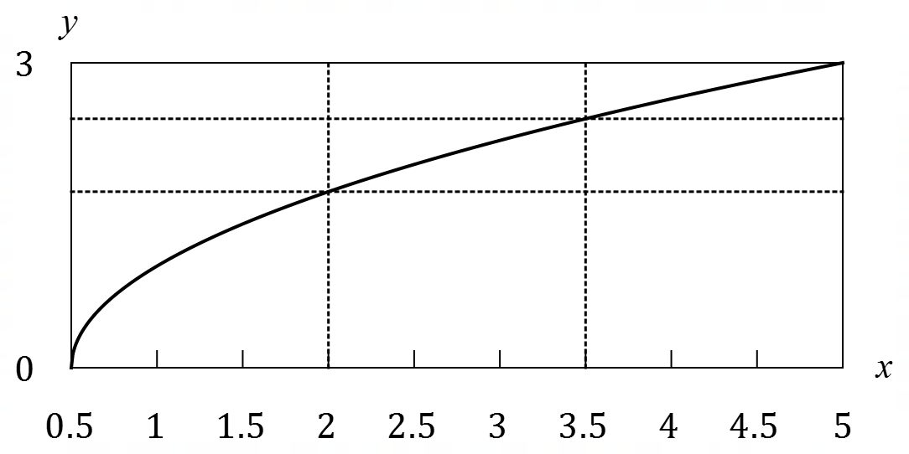
The graph of $y=\sqrt{2x-1}$ between
$x=0.5$ and $x=5$ is shown at right.
Approximate values for $\sqrt{3}$ and $\sqrt{6}$
are $1.73$ and $2.45$ respectively.

(a) Use the areas of the rectangles shown to explain why $6.27<\int_{0.5}^{5}{\underset{ }{\overset{ }{\sqrt{2x-1}}}}dx<10.77$. (3 marks)

Solution
The value of the integral is the area under the curve between $0.5$ and $5$. The area of the inscribed rectangles is $\frac{3}{2}\left(0+1.73+2.45\right)=6.27$, an underestimate. The area of the circumscribed rectangles is $\frac{3}{2}\left(1.73+2.45+3\right)=10.77$, an overestimate. Hence the value of the integral must lie between these two.

Specific Behaviours
Derives area approximation using inscribed rectangles
ü Derives area approximation using circumscribed rectangles
ü Explains inequality
(If used surd form, 1 mark deducted)

(b) Evaluate $\int_{0.5}^{5}{\underset{ }{\overset{ }{\sqrt{2x-1}}}}dx$. (3 marks)

Solution
$$\int_{0.5}^{5}{{\left(2x-1\right)}^{\frac{1}{2}}}dx={\left[{\frac{1}{3}\left(2x-1\right)}^{\frac{3}{2}}\right]}_{0.5}^{5} \\ =\frac{1}{3}{\left(9\right)}^{\frac{3}{2}}-\frac{1}{3}{\left(0\right)}^{\frac{3}{2}} \\ =9$$

Specific Behaviours
ü Obtains ${\left(2x-1\right)}^{1.5}$ term in antiderivative
ü Obtains correct antiderivative
ü Substitutes both bounds and simplifies
(1 mark deducted, if answer was given in surd form $\frac{\sqrt{9^{3}}}{3}$)

(c) Evaluate $\int_{0.5}^{5}{\left(\underset{ }{\overset{ }{\sqrt{2x-1}}}-3\right)}dx$. (2 marks)

Solution
$$\int_{0.5}^{5}{\left(\sqrt{2x-1}-3\right)}dx=\int_{0.5}^{5}{\sqrt{2x-1}}dx-\int_{0.5}^{5}{3}dx \\ =9-4.5×3=-4.5$$

Specific Behaviours
Uses linearity
ü Correct value

Question 4 (8 marks)

A student observes the graphs of three binomial distributions with the assigned random variables $A,B$ and $C$ for each graph. For all three distributions, the value of $n$ is constant, but the values of $p$ are 0.25, 0.5 and 0.9 respectively.

- The student notes that one of the distributions produced a graph that is skewed to the right (long tail to the right). Which of the values of $p$ were used to produce this graph? Give justification for your choice. (2 marks)

Solution
$$p=0.25$$
A lower value for the probability of success will skew the data to the right as this will decrease the overall expected value.

Specific Behaviours
- States the correct value of $p$
- Justifies with regard to the expected value of the distribution

- The standard deviation when $p=0.25$ is 6. Determine the value of $n$. (3 marks)

Solution
$$σ^{2}=36$$
$$σ^{2}=np\left(1-p\right)$$

$$36=\frac{3n}{16}$$

$$n=192$$

Specific Behaviours
- Determines the variance of the distribution
- Establishes an equation to solve $n$ using the variance
- Solves for $n$ (accept correct integer or fraction value)

- Using your answer from part b), show how to calculate the following without the use of a calculator. Do not evaluate your answer.

  - $P(A=4)$ (1 mark)

Solution
$$P\left(A=4\right)=\left(\begin{matrix}192 \\ 4\end{matrix}\right)×{0.25}^{4}×(1-0.25)^{188}$$

Specific Behaviours
- Gives the correct expression for determining $P(A=4)$

  - $P(C≥190)$ (2 marks)

Solution
$$P\left(C≥190\right)=\left(\begin{matrix}192 \\ 190\end{matrix}\right)×{0.9}^{190}×(1-0.9)^{2}+\left(\begin{matrix}192 \\ 191\end{matrix}\right)×{0.9}^{191}×(1-0.9)^{1}+\left(\begin{matrix}192 \\ 192\end{matrix}\right)×{0.9}^{192}×(1-0.9)^{0}$$

Specific Behaviours
- Shows the sum of probabilities
- Gives the correct expression for determining $P(C≥190)$

Question 5 (6 marks)
- Determine $\frac{d}{dx}(\cos^{3}\left(4x\right))$ (2 marks)
Solution
$$\frac{d}{dx}\left(\cos^{3}\left(4x\right)\right)=3×-4\sin{4x}×\cos^{2}\left(4x\right)=-12\sin{4x}\cos^{2}\left(4x\right)$$

Specific Behaviours
- Demonstrates the use of the chain rule
- Determines the correct expression for the derivative

- Hence, evaluate the following in exact form: $\int_{0}^{\frac{π}{3}}{-sin 4x cos^{2}\left(4x\right)dx}$ (4 marks)
Solution
By FTC: $\int{-sin 4x cos^{2}\left(4x\right)dx}=\frac{1}{12}\int{-12\sin{4x}\cos^{2}\left(4x\right)dx}$

$=\frac{1}{12}\int{\frac{d}{dx}\left(\cos^{3}\left(4x\right)\right)dx}$

$=\frac{1}{12}\cos^{3}\left(4x\right)+c$

$$\int_{0}^{\frac{π}{3}}{-sin 4x cos^{2}\left(4x\right)dx}=\left[\frac{1}{12}\cos^{3}\left(4x\right)\right]\begin{matrix}\frac{π}{\begin{aligned}3 \\ \end{aligned}} \\ 0\end{matrix}$$

$$\frac{1}{12}\cos^{3}\left(\frac{4π}{3}\right)-\frac{1}{12}\cos^{3}\left(0\right)=-\frac{1}{96}-\frac{1}{12}$$

$$∴\int_{0}^{\frac{π}{3}}{-sin 4x cos^{2}\left(4x\right)dx}=-\frac{3}{32}$$

Specific Behaviours
- Uses FTC to establish the antiderivative function
- Determines the antiderivative function
- Substitutes the limits
- Evaluates the integral exactly

Question 6 (13 marks)

The graph of $g\left(x\right)$ is given as below, which consists of a semi-circle for $-7≤x≤-1$ and a triangle for $-1≤x≤8.$
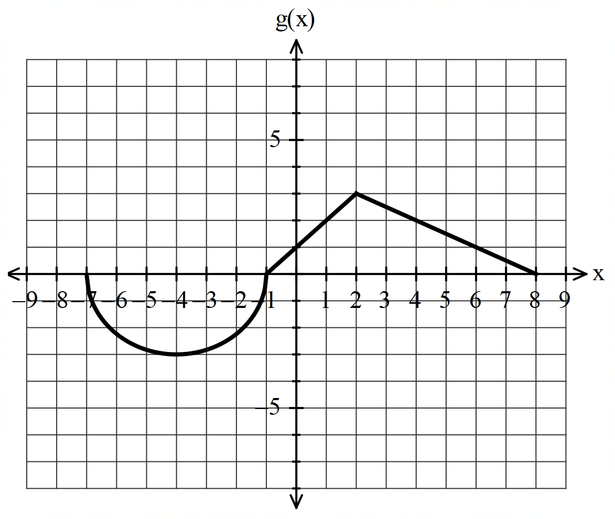

Given that $f\left(x\right)=\int_{-7}^{x}{g\left(t\right) dt}$, where $-7≤x≤8$.
- Determine the intervals where $f(x)$ is increasing and decreasing, respectively.
(2 marks)

Solutions
Increasing at $-1≤x≤8$and decreasing at $-7≤x≤-1$

Specific Behaviours
- Determines the correct increasing interval.
- Determines the correct decreasing interval.

- Determine the intervals where $f(x)$ is concave up and concave down, respectively.
(2 marks)
Solutions
Concave up at $-4≤x≤2;$concave down at $-7≤x≤-4$ and $2≤x≤8$

Specific Behaviours
- Determines the correct concave up interval.
- Determines the correct concave down intervals

- Determine the value(s) of $x$ when $f\left(x\right)$reaches any stationary point(s) (2 marks)

Solutions
stationary at $x=-7,-1 \& 8$

Specific Behaviours
- Determines at x=-1
- Determines at x=-7 & 8

- Determine the exact values of $f\left(-1\right)$. (2 marks)
Solutions
$$f\left(-1\right)=-\left(\frac{1}{2}π{\left(3\right)}^{2}\right)=-\frac{9}{2}π$$

Specific Behaviours
- Uses area under the curve.
- Coverts into negative integral.

- Determine the exact values $f(8)$. (2 marks)

Solutions
$$f\left(8\right)=-\frac{9}{2}π+\frac{1}{2}\left(9\right)\left(3\right)=-\frac{9}{2}π+\frac{27}{2}$$

Specific Behaviours
- Determines the correct area of triangle.
- Determines the correct integral.

- Sketch the graph of $f(x)$ in the axes provided below, for $-7≤x≤8.$ Label key features. (3 marks)

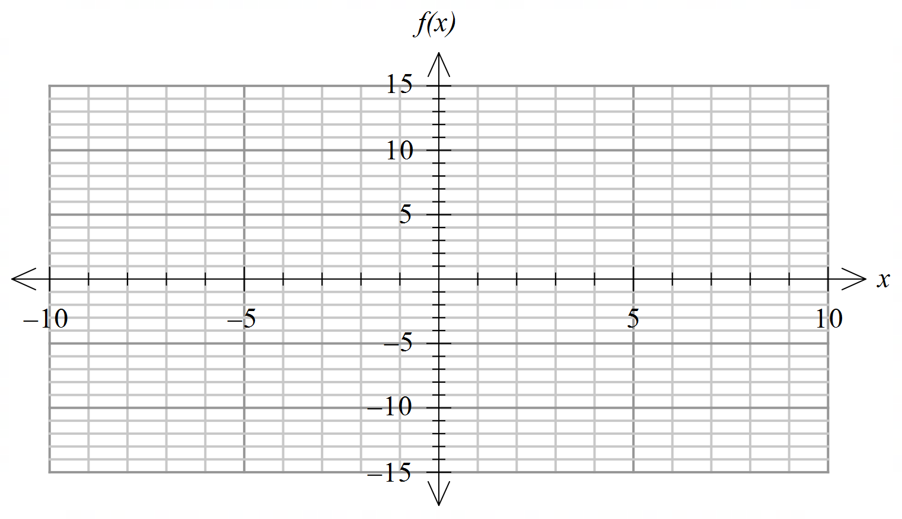
Solutions
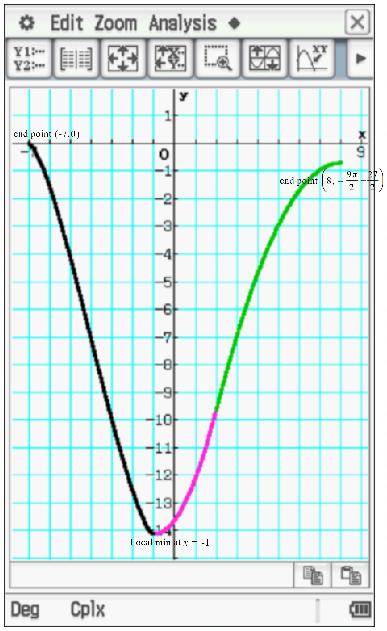

Note: Students sketch based on concavity and information above- exact graph on classpad is for teacher use only

Specific Behaviours
- shape with correct concavity
√ Labels local min with coords_and plotted accurately (accept approx.)
- Labels endpoints with coords and plotted accurately (accept approx.)

Additional working space
Question number: ________

Additional working space
Question number: ________

